# Project 5 Neo4j Graph Database

## A high-level description of the business use case

* *The business use case I have chosen is Talent.net which infers connections with people*
* *It has Persons who work for a Company, along with their names and titles, the Projects that they worked on and with whom they worked with. Then it has the interests of people as well.*

## A description of the data model

* Nodes are Person, Company, Projects, and Interests.
* Relationships are one of the following:
  + [WorkedAt], [WorksAt], [WorkedOn], [likes]
  + Person – Name, Title
  + Company – Name
  + Projects – Name
  + Interests – Name

## A small sample of data

|  |  |  |  |  |  |  |  |
| --- | --- | --- | --- | --- | --- | --- | --- |
| **Name** | **WorkedAt** | **WorksAt** | **Worked On** | **WorkedOn1** | **WorkedOn2** | **Interests1** | **Interests2** |
| Matt G | Wyeth | BMG | Strategy | Sales |  | Golf | Travel |
| Dan S | Wyeth | BMG | Sales | Strategy | Operations | Book Club |  |
| Fiona B | Viro | BMG | Operations | BI | CRM | Travel | Health |
| Steve R | Viro | BMG | Operations | BI | CRM | Drums | Cuisine |
| Shazia K | Pfizer | BMG | BI | Operations |  | Health |  |
| Anna N | Pfizer | BMG | CRM |  |  | Marathon |  |
| Brian H | Endo | BMG | BI |  |  | Cuisine |  |
| David C | Endo | BMG | Marketing |  |  | Travel |  |

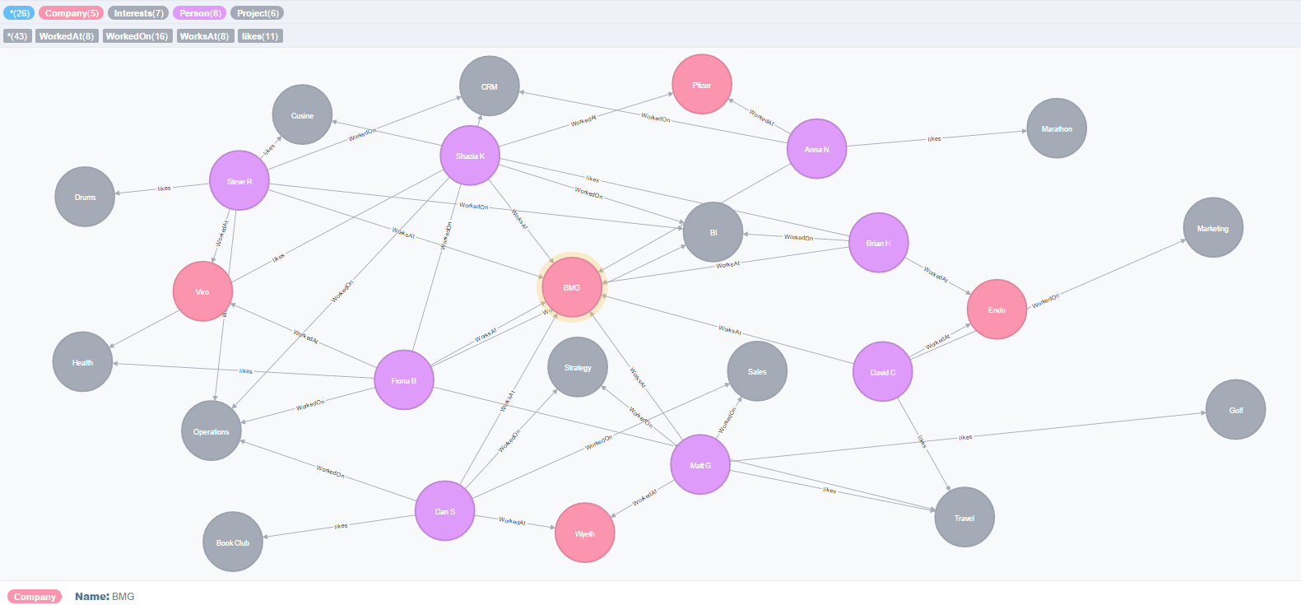

## The code for queries to acquire and manage the data in Neo4j

// Create Person Nodes

//C:\Users\SR\Documents\IS607\Project5\People.csv

LOAD CSV WITH HEADERS FROM "file:C:/Users/SR/Documents/IS607/Project5/People.csv" AS Person

CREATE (n:Person{Name: Person.Name, Title:Person.Title});

//Create Comapany Nodes

LOAD CSV WITH HEADERS FROM "file:C:/Users/SR/Documents/IS607/Project5/Company.csv" AS Company

CREATE (m:Company {Name: Company.Company});

//Create Department Node

LOAD CSV WITH HEADERS FROM "file:C:/Users/SR/Documents/IS607/Project5/Project.csv" AS d

CREATE (m:Project {Name: d.Name});

//Create Interests Node

LOAD CSV WITH HEADERS FROM "file:C:/Users/SR/Documents/IS607/Project5/Interests.csv" AS Interests

CREATE (m:Interests {Name: Interests.Interests});

//-------------------------------------------------------------------------------------------

//Create relationship between People and Company in the past

LOAD CSV WITH HEADERS FROM "file:C:/Users/SR/Documents/IS607/Project5/Data.csv" AS w

MATCH (a: Person {Name: w.Name}), (b:Company {Name: w.WorkedAt})

CREATE (a) -[r:WorkedAt]-> (b)

//Create relationship between People and Company

LOAD CSV WITH HEADERS FROM "file:C:/Users/SR/Documents/IS607/Project5/Data.csv" AS w

MATCH (a: Person {Name: w.Name}), (b:Company {Name: w.WorksAt})

CREATE (a) -[r:WorksAt]-> (b)

//Create relationship between People and Company currently

// WorkedOn x 3

LOAD CSV WITH HEADERS FROM "file:C:/Users/SR/Documents/IS607/Project5/Data.csv" AS x

MATCH (a: Person {Name: x.Name}), (b:Project {Name: x.WorkedOn1})

CREATE (a) -[r:WorkedOn]-> (b)

LOAD CSV WITH HEADERS FROM "file:C:/Users/SR/Documents/IS607/Project5/Data.csv" AS x

MATCH (a: Person {Name: x.Name}), (b:Project {Name: x.WorkedOn2})

CREATE (a) -[r:WorkedOn]-> (b)

LOAD CSV WITH HEADERS FROM "file:C:/Users/SR/Documents/IS607/Project5/Data.csv" AS x

MATCH (a: Person {Name: x.Name}), (b:Project {Name: x.WorkedOn3})

CREATE (a) -[r:WorkedOn]-> (b)

// Interests x 2

LOAD CSV WITH HEADERS FROM "file:C:/Users/SR/Documents/IS607/Project5/Data.csv" AS x

MATCH (a: Person {Name: x.Name}), (b:Interests {Name: x.Interests1})

CREATE (a) -[r:likes]-> (b)

LOAD CSV WITH HEADERS FROM "file:C:/Users/SR/Documents/IS607/Project5/Data.csv" AS x

MATCH (a: Person {Name: x.Name}), (b:Interests {Name: x.Interests2})

CREATE (a) -[r:likes]-> (b)

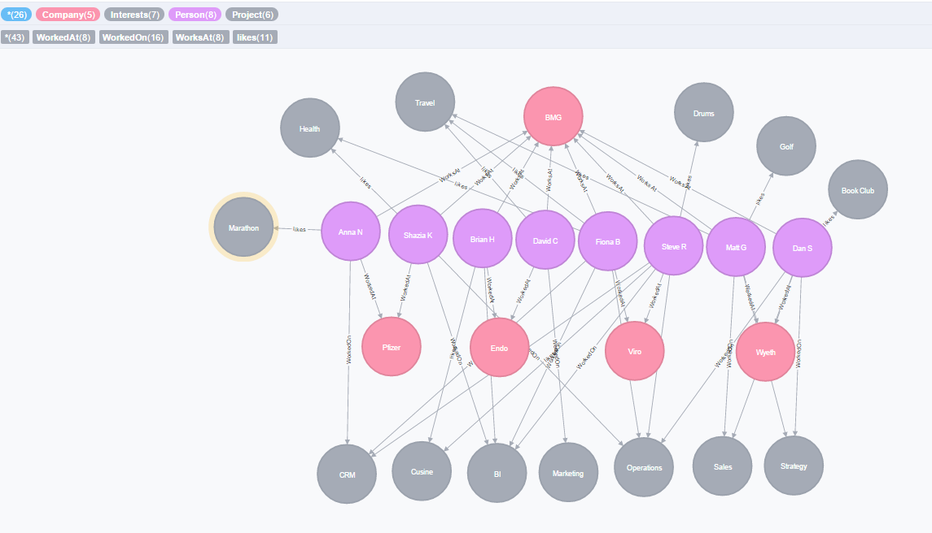

## The code for queries to access and analyze the data for your use case

1. Who works for BMG?

MATCH (p:Person) - [n:WorksAt] - (c:Company) where c.Name = 'BMG'

RETURN p, c, n

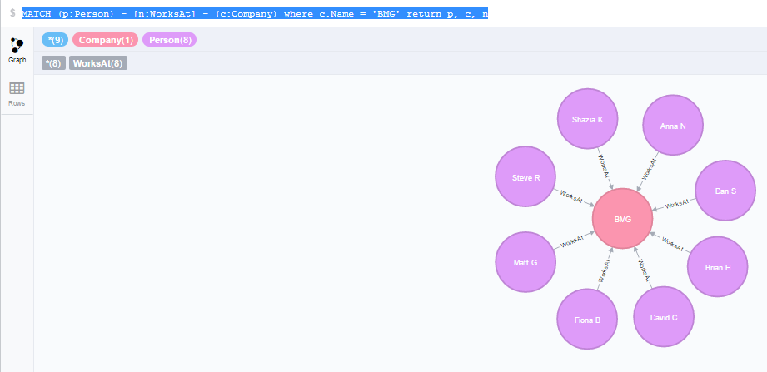

2) Who worked at Viro

MATCH (p:Person) - [n:WorksAt] - (c:Company) where c.Name = 'Viro'

RETURN p, c, n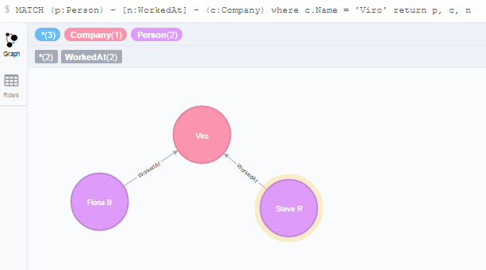

3) What Projects did Dan S work on?

MATCH (p:Person)-[w:WorkedOn]->(Project) WHERE p.Name = "Dan S"

RETURN p.Name, w, Project.Name

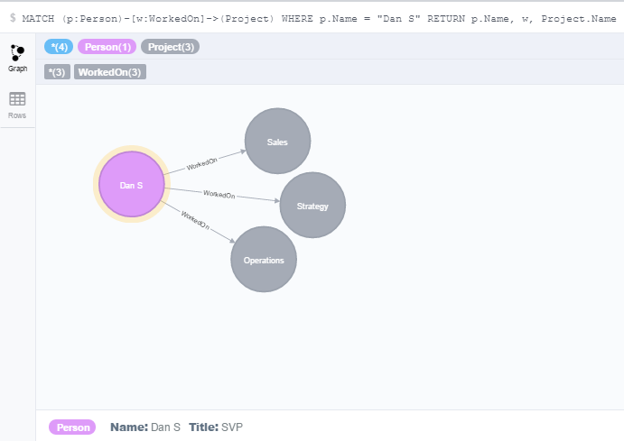

4) Who has worked on the same projects as Dan S has?

MATCH (p:Person)-[w:WorkedOn]->(Project) - [y:WorkedOn] - (x:Person) WHERE p.Name = "Dan S"

RETURN x.Name, w, y, Project.Name

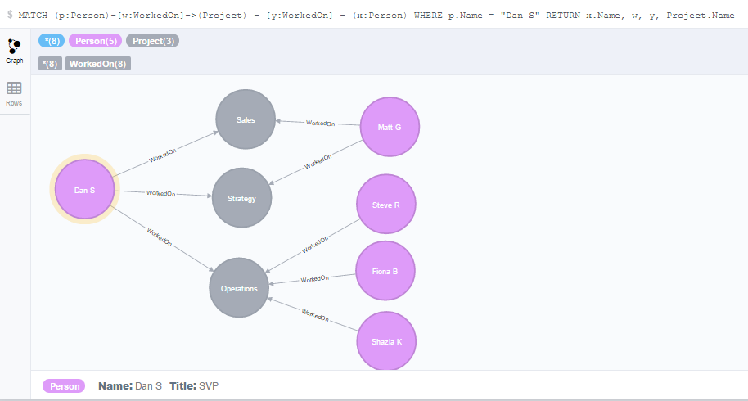

5) Who are the people who worked with Dan S and also like to Travel?

MATCH (p:Person)-[w:WorkedOn]->(Project) - [y:WorkedOn] - (x:Person) - [i:likes] - (o:Interests) WHERE p.Name = "Dan S" and o.Name = "Travel"

RETURN x.Name, w, y, Project.Name, i, o

